**File Uploading Utility**

**(Client System to Oracle Application Server)**

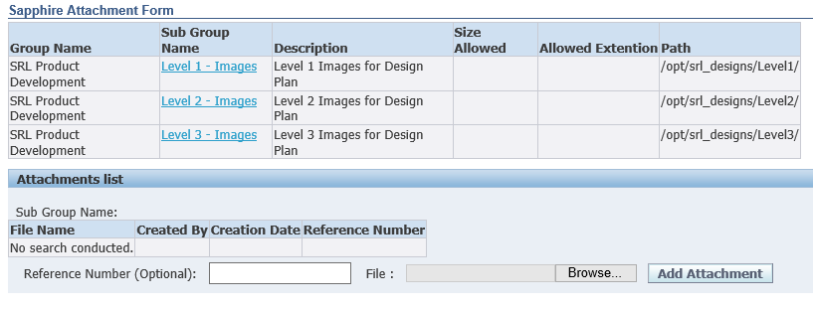

Table of Contents

INTRODUCTION 3

Scope 3

Framework 3

**Setup** 4

Quality Plan 4

# INTRODUCTION

## Scope

**File Uploading Utility is Customized solution in which users will able to upload file from their system to application server. In this Utility, we segregate user’s data by different user groups.**

## Framework

**This utility is design in Oracle Application Framework (EBS 12.1.3) using Java as frontend and PLSQL as backend. This utility is configured with Oracle 11g database & Oracle E-Business 12.1.3 application server.**

# **Setup**

## Quality Plan

For this utility we setup quality plan and Profile Option. That are used to record setup transactions and apply security options.

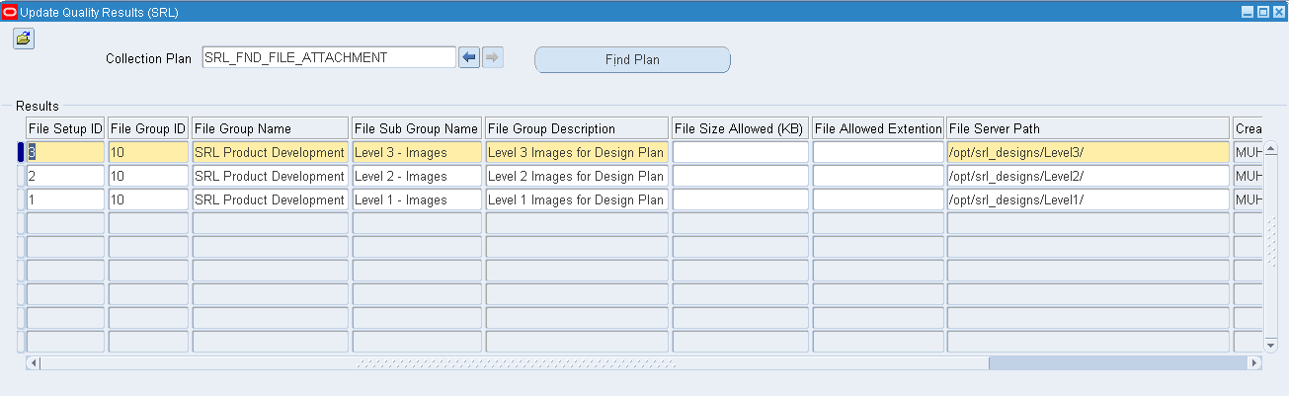I (Figure: 1)

In Quality Plan **“SRL_FND_FILE_ATTACHMENT”,** we will enter our setup record. User data will be segregated in different groups and its server path.

## Profile Options

We create new profile option. That will be assign to User and user can upload file using that Group.

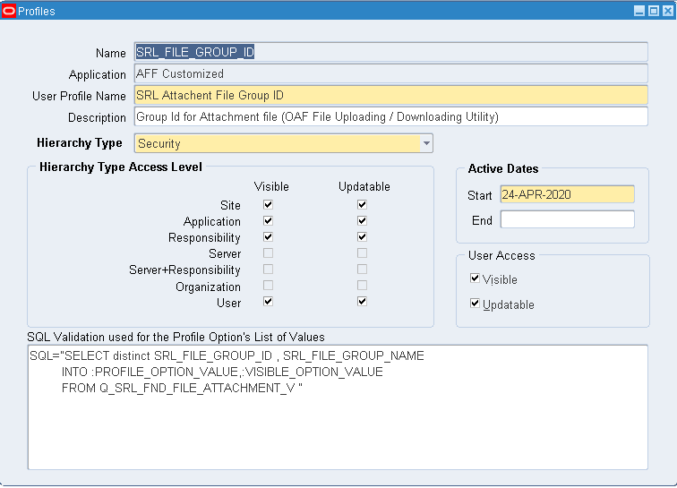

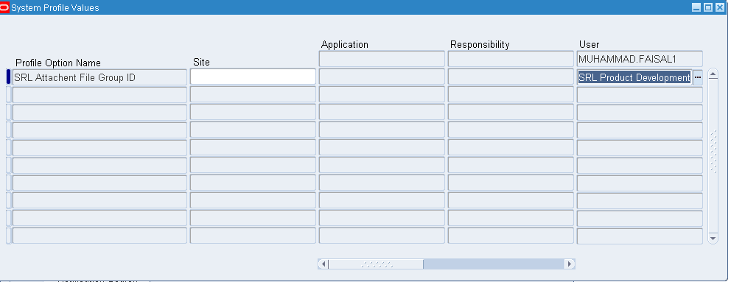

This Profile option can be site / Application / Responsibility level. Using this feature user will able to access multiple Groups of data.

## Function

Defined new function and assign this function to menu in application. In this function we define our OAFpage URL in it.

## 

## Database Scripts

*-- Create table*

create table STM_CUST.SRL_FND_ATTACHMENTS

(

transaction_id NUMBER,

filename VARCHAR2(200),

creation_date DATE,

created_by NUMBER,

last_updated_by NUMBER,

last_update_login NUMBER,

last_update_date DATE,

form_name VARCHAR2(100),

content_type VARCHAR2(200),

attachments_id NUMBER

)

CREATE SYNONYM SRL_FND_ATTACHMENTS FOR STM_CUST.SRL_FND_ATTACHMENTS;

select * from SRL_FND_ATTACHMENTS

## Shell Scripts

--This script import our custom OAF page on server.

java oracle.jrad.tools.xml.importer.XMLImporter $JAVA_TOP/SRL/oracle/apps/fnd/file/webui/page1.xml -rootdir $JAVA_TOP -username apps -password PasswordOFApps -dbconnection "(DESCRIPTION=(ADDRESS=(PROTOCOL=tcp)(HOST=HostIP)(PORT=HostPort))(CONNECT_DATA=(SID= PROD_SID)))"

## Java Classes

package SRL.oracle.apps.fnd.file.webui;

import SRL.oracle.apps.fnd.file.server.FileSetupVOImpl;

import SRL.oracle.apps.fnd.file.server.FileSetupVORowImpl;

import SRL.oracle.apps.fnd.file.server.SrlFndAttachmentsViewImpl;

import SRL.oracle.apps.fnd.file.server.SrlFndAttachmentsViewRowImpl;

import SRL.oracle.apps.fnd.file.server.UploadFileAMImpl;

import java.io.BufferedInputStream;

import java.io.File;

import java.io.FileInputStream;

import java.io.FileOutputStream;

import java.io.IOException;

import java.io.InputStream;

import java.io.OutputStream;

import java.sql.SQLException;

import javax.servlet.ServletOutputStream;

import javax.servlet.http.HttpServletResponse;

import oracle.apps.fnd.common.VersionInfo;

import oracle.apps.fnd.framework.OAException;

import oracle.apps.fnd.framework.server.OADBTransaction;

import oracle.apps.fnd.framework.webui.OAControllerImpl;

import oracle.apps.fnd.framework.webui.OAPageContext;

import oracle.apps.fnd.framework.webui.OAWebBeanConstants;

import oracle.apps.fnd.framework.webui.beans.OAWebBean;

import oracle.apps.fnd.framework.webui.beans.form.OAFormValueBean;

import oracle.apps.fnd.framework.webui.beans.layout.OAHeaderBean;

import oracle.apps.fnd.framework.webui.beans.message.OAMessageStyledTextBean;

import oracle.apps.fnd.framework.webui.beans.message.OAMessageTextInputBean;

import oracle.cabo.ui.data.DataObject;

import oracle.ias.cache.CacheAccess;

import oracle.jbo.RowSetIterator;

import oracle.jbo.domain.BlobDomain;

import oracle.jbo.domain.Number;

*/\*\**

*\* Controller for ...*

*\*/*

public class FileController extends OAControllerImpl {

public static final String RCS_ID = "$Header$";

public static final boolean RCS_ID_RECORDED =

VersionInfo.recordClassVersion(RCS_ID, "%packagename%");

*/\*\**

*\* Layout and page setup logic for a region.*

*\* @param pageContext the current OA page context*

*\* @param webBean the web bean corresponding to the region*

*\*/*

public void processRequest(OAPageContext pageContext, OAWebBean webBean) {

super.processRequest(pageContext, webBean);

UploadFileAMImpl am = (UploadFileAMImpl)pageContext.getApplicationModule(webBean);

FileSetupVOImpl fileStepUpV = (FileSetupVOImpl) am.getFileSetupVO1();

fileStepUpV.executeQuery();

}

*/\*\**

*\* Procedure to handle form submissions for form elements in*

*\* a region.*

*\* @param pageContext the current OA page context*

*\* @param webBean the web bean corresponding to the region*

*\*/*

public void processFormRequest(OAPageContext pageContext,

OAWebBean webBean) {

///Super object

super.processFormRequest(pageContext, webBean);

UploadFileAMImpl am =

(UploadFileAMImpl)pageContext.getApplicationModule(webBean);

//Button & Partial Process request Event

if (pageContext.getParameter(OAWebBeanConstants.EVENT_PARAM) != null) {

String EventName =

new String(pageContext.getParameter(OAWebBeanConstants.EVENT_PARAM));

// Coding for Event

this.ActionEvent(pageContext, webBean, EventName, am);

}

}

/// actionEvent handler

private void ActionEvent(OAPageContext pageContext, OAWebBean webBean,

String EventName, UploadFileAMImpl am) {

if (EventName.equals("UploadFileToDB")) {

this.UploadFileToDB(pageContext, webBean, am);

}

if (EventName.equals("Filename")) {

this.downlaodFileFromServer(pageContext,webBean,am);

}

//SubGroupName

if (EventName.equals("SubGroupName")) {

this.QueryDetails(pageContext,webBean,am);

}

}

///Save Data

public void Save(UploadFileAMImpl am) {

am.getOADBTransaction().commit();

}

private void UploadFileToDB(OAPageContext pageContext, OAWebBean webBean,

UploadFileAMImpl am) {

//Get Current Seected Record of Header.

FileSetupVORowImpl setupRec = (FileSetupVORowImpl) this.Get_SetupID(pageContext,webBean,am);

if (setupRec==null)

{

throw new OAException("Please select any group from Header for upload files.",OAException.ERROR);

}

//AttachmentFile Data

DataObject fileUploadData =

(DataObject)pageContext.getNamedDataObject("AddAttachmentFile");

String fileName =

(String)fileUploadData.selectValue(null, "UPLOAD_FILE_NAME");

if (fileName == null) {

throw new OAException("Please select attachment file for upload.",

OAException.ERROR);

}

// Document Informations / referenceNumber.GetValue

OAMessageTextInputBean referenceNumber = (OAMessageTextInputBean) webBean.findChildRecursive("referenceNumber");

String rf ;

Number refNum=null;

if (referenceNumber.getValue(pageContext)!=null)

{

try {

rf=(String)referenceNumber.getValue(pageContext);

refNum = new Number(rf);

}

catch (NumberFormatException e) {

// TODO

throw new OAException("Please enter valid number in Reference field..",OAException.ERROR);

}

catch (SQLException e) {

// TODO

throw new OAException(e.getMessage(),OAException.ERROR);

}

}

SrlFndAttachmentsViewImpl AttachmentVo =

(SrlFndAttachmentsViewImpl)am.getSrlFndAttachmentsView1();

AttachmentVo.executeQuery();

SrlFndAttachmentsViewRowImpl attachmentRow =

(SrlFndAttachmentsViewRowImpl)AttachmentVo.createRow(); //Create new Record

AttachmentVo.insertRow(attachmentRow);

OADBTransaction DBT =

(OADBTransaction)am.getDBTransaction(); /// DB Transaction

Number Attachment_id =

new Number(DBT.getSequenceValue("SRL_FND_ATTACHMENT_SEQ")); //attachmentID

attachmentRow.setAttachmentsId(Attachment_id);

attachmentRow.setFilename(fileName);

attachmentRow.setFormName(setupRec.getSrlFileSetupId());

attachmentRow.setContentType((String)fileUploadData.selectValue(null,

"UPLOAD_FILE_MIME_TYPE"));

if (refNum!=null)

{

attachmentRow.setTransactionId(refNum); //assign Transaction ID

}

this.uploadFileToServer(pageContext, fileName,

createBlobDomain(fileUploadData),setupRec.getSrlFileServerPath());

///

this.Save(am);

//Set Details Where Clause

AttachmentVo.setWhereClause("1=2");

AttachmentVo.executeQuery();

AttachmentVo.setWhereClause(null);

AttachmentVo.setWhereClause("form_name="+setupRec.getSrlFileSetupId());

AttachmentVo.executeQuery();

}

private BlobDomain createBlobDomain(DataObject pfileUploadData) {

// init the internal variables

InputStream in = null;

BlobDomain blobDomain = null;

OutputStream out = null;

try {

String pFileName =

(String)pfileUploadData.selectValue(null, "UPLOAD_FILE_NAME");

BlobDomain uploadedByteStream =

(BlobDomain)pfileUploadData.selectValue(null, pFileName);

// Get the input stream representing the data from the client

in = uploadedByteStream.getInputStream();

// create the BlobDomain datatype to store the data in the db

blobDomain = new BlobDomain();

// get the outputStream for hte BlobDomain

out = blobDomain.getBinaryOutputStream();

byte buffer[] = new byte[8192];

for (int bytesRead = 0;

(bytesRead = in.read(buffer, 0, 8192)) != -1; )

out.write(buffer, 0, bytesRead);

in.close();

} catch (IOException e) {

e.printStackTrace();

} catch (SQLException e) {

e.fillInStackTrace();

}

// return the filled BlobDomain

return blobDomain;

}

public void uploadFileToServer(OAPageContext pageContext, String fileName,

BlobDomain pBlobDomain,String filePath) {

try {

FileOutputStream output =

new FileOutputStream(new File(filePath, fileName));

for (int bytes = 0; bytes < pBlobDomain.getLength(); bytes++) {

output.write(pBlobDomain.getInputStream().read());

}

output.close();

} catch (Exception e) {

throw new OAException("File Uploading error " + e.getMessage(),

OAException.ERROR);

}

}

public void downlaodFileFromServer(OAPageContext pageContex,OAWebBean webBean,UploadFileAMImpl am)

{

//Get Current Seected Record of Header.

FileSetupVORowImpl setupRec = (FileSetupVORowImpl) this.Get_SetupID(pageContex,webBean,am);

HttpServletResponse response =

(HttpServletResponse)pageContex.getRenderingContext().getServletResponse();

SrlFndAttachmentsViewRowImpl attachmnetROw = (SrlFndAttachmentsViewRowImpl) am.findRowByRef(pageContex.getParameter(OAWebBeanConstants.EVENT_SOURCE_ROW_REFERENCE)) ;

String fileType = (String)attachmnetROw.getContentType();

String fileName = attachmnetROw.getFilename();

String fileNameWithPath = setupRec.getSrlFileServerPath()+fileName;

//Get File Name

File fileToDownload = null;

try {

fileToDownload = new File(fileNameWithPath);

} catch (Exception e) {

throw new OAException("Invalid File Path or file does not exist.");

}

///Read File

if (!fileToDownload.canRead()) {

throw new OAException("Not Able to read the file.");

}

response.setContentType(fileType);

response.setContentLength((int)fileToDownload.length());

response.setHeader("Content-Disposition", "attachment; filename=\"" + fileName + "\"");

InputStream in = null;

ServletOutputStream outs = null;

try {

outs = response.getOutputStream();

in = new BufferedInputStream(new FileInputStream(fileToDownload));

int ch;

while ((ch = in.read()) != -1) {

outs.write(ch);

}

} catch (IOException e) {

// TODO

e.printStackTrace();

} finally {

try {

outs.flush();

outs.close();

if (in != null) {

in.close();

}

} catch (Exception e) {

e.printStackTrace();

}

}

}

*/*Query Details Region*/*

private void QueryDetails(OAPageContext pageContext, OAWebBean webBean, UploadFileAMImpl am)

{

//This Parameter is defined in Event parameters of Field , Current Row SetupID

String SrlFileSetupId = (String) pageContext.getParameter("SrlFileSetupId");

//Set Setup ID in FormValue *--FormValue Name is SetupID.*

this.Set_SetupID(pageContext,webBean,SrlFileSetupId);

//Get SetUpRecord

FileSetupVORowImpl setupRec = (FileSetupVORowImpl)this.Get_SetupID(pageContext,webBean,am);

// Variable of View

SrlFndAttachmentsViewImpl attachmentVO = (SrlFndAttachmentsViewImpl) am.getSrlFndAttachmentsView1();

//Set Details Where Clause

attachmentVO.setWhereClause("1=2");

attachmentVO.executeQuery();

attachmentVO.setWhereClause(null);

attachmentVO.setWhereClause("form_name="+setupRec.getSrlFileSetupId());

attachmentVO.executeQuery();

//Set Details Text

OAMessageStyledTextBean TextB = (OAMessageStyledTextBean)webBean.findChildRecursive("DetailsText");

TextB.setValue(pageContext,setupRec.getSrlFileSubGroupName()+"("+setupRec.getSrlFileSubGroupDescription()+")");

}

//Get SetUp Record

public FileSetupVORowImpl Get_SetupID (OAPageContext pageContext, OAWebBean webBean, UploadFileAMImpl am)

{

//QueryDetails method Store Value SetupID , Now we will Get it and use in below code.

OAFormValueBean FV = (OAFormValueBean) webBean.findChildRecursive("SetupID");

String l_FV = (String) FV.getValue(pageContext);

if (l_FV==null)

{

throw new OAException("Please select any group from Header for upload files.",OAException.ERROR);

}

//Setup view Object

FileSetupVOImpl setupVO = (FileSetupVOImpl)am.getFileSetupVO1();

//Iterator of Setup View and set its Ranges

RowSetIterator setupVO_Itr = this.GetRowIterator(setupVO);

setupVO_Itr.setRangeStart(0);

setupVO_Itr.setRangeStart(setupVO.getRowCount());

//Setup view Record object

FileSetupVORowImpl setupVO_rec = null;

// Find the Record that is Select for Query Details Block and Upload Attachment

//

for(int i=0;i<setupVO.getRowCount();i++)

{

/// Get Row

// (0-Last Record) where Record=Parameter /Return record/ else /Null/

setupVO_rec =(FileSetupVORowImpl)setupVO_Itr.getRowAtRangeIndex(i);

if (l_FV.equals(setupVO_rec.getSrlFileSetupId()))

{

return setupVO_rec;

}

}

return null;

}

//Set SetUpID

public void Set_SetupID (OAPageContext pageContext, OAWebBean webBean, String SetupID)

{

//Set SetupID Value

OAFormValueBean FV = (OAFormValueBean) webBean.findChildRecursive("SetupID");

FV.setValue(pageContext,SetupID);

}

*/\**

*\* GetRowIterator : Get RowSetIterator of View Objetc ,incase RowSetIterator is not assosiated then Create it.*

*\* @Param ViewObjectIMP*

*\* */*

public RowSetIterator GetRowIterator(FileSetupVOImpl pViewObject)

{

if (pViewObject.getRowSetIterator() == null)

{

//Create New RowIterator

return pViewObject.createRowSetIterator("FileSetupVOImpl");

}

else

{

//Create Existing RowIterator

return pViewObject.getRowSetIterator();

}

}

}

# User Manual

Open Form From your responsibility menu.

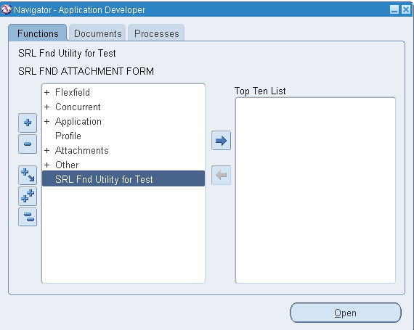

Form will be open after click on menu function.

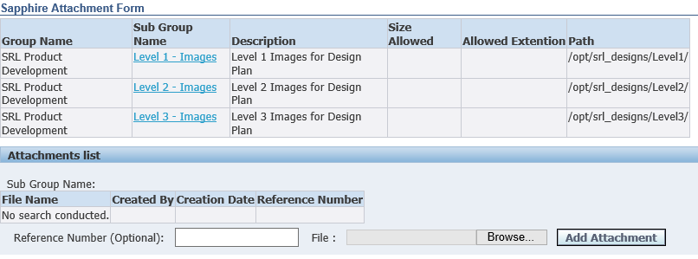

In this above screenshot, there are two section available for user. Main section show all groups that are assigned to user.

Now click on any Group (underline with blue text) in which you want to upload file.

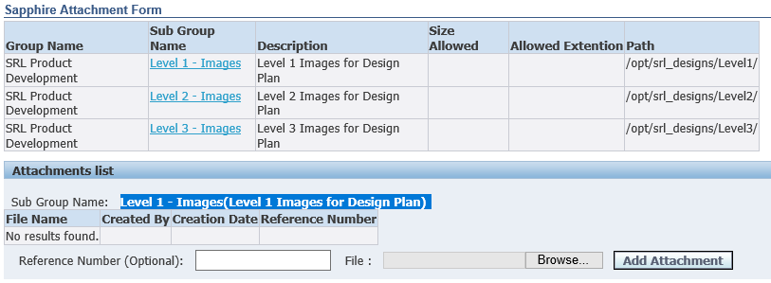

As you click on Sub Group second section “Attachment list” will show your sub group name as highlighted and also it will show already entered records.

Now you can enter new record.

1. Reference number (optional) can be used for user-reference fields.
2. Select file by clicking Browse button.
3. Press Add Attachment Button

